Description of motion

The world consists of mass (m), space (l) and time (t), whose units are kg, m and s respectively in the International System (SI).

Scientific Notation

2.3 x 10⁻³,

Scalars
Scalars are the quantities with no associated direction, normally used to describe objects and situations, such as mass (5 kg), length (3.4 m), time (30 s), temperature (20 °C),

Vectors
Vectors are the quantities defined by both magnitude and direction, normally used to describe actions, such as displacement (move to right 3 m), velocity (20 m s⁻¹ to east), acceleration, force (20N forward), momentum, and impulse.

adding vectors in one and two dimensions

Subtracting vectors in one and two dimensions

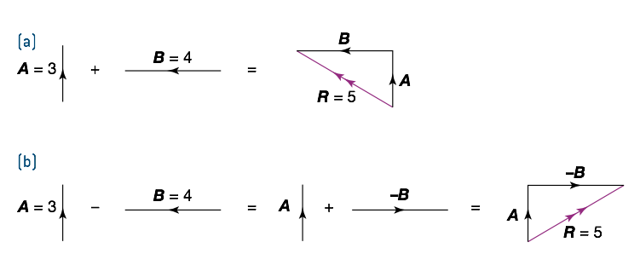
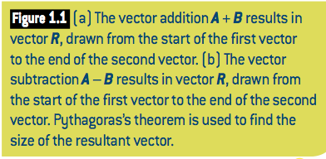

Vector components

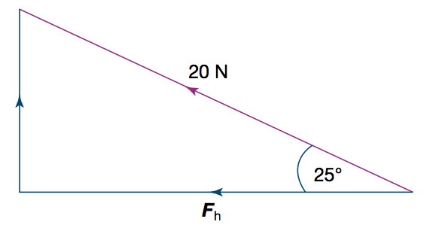
Fig. The vector (20 N) resolved into a horizontal component F_{h} and a vertical component F_{v}.

Algebraic representation of vector addition and subtraction

